Westlake Entrada

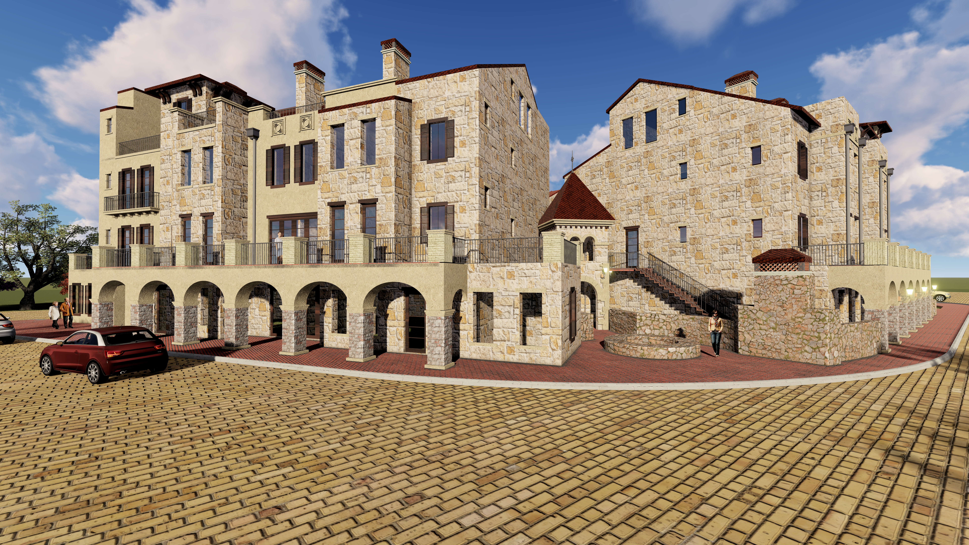

Luxury Town Homes Built By PentaVia Custom Homes

TH-1 2587 sq. ft. + 225 sq. ft. terrace $ 1,165,000
Pure (59 Cortes Drive)

TH-2 2667 sq. ft. + 176 sq. ft. terrace $ 1,195,000
Motif (61 Cortes Drive)

TH-3 2397 sq. ft. + 325 sq. ft. terrace $ 1,075,000
Contour (63 Cortes Drive)

TH-4 2836 sq. ft. + 320 sq. ft. terrace $ 1,275,000
+ 162 sq. ft. courtyard
Motif (65 Cortes Drive)

TH-5 2672 sq. ft. + 312 sq. ft. terrace $ 1,205,000
+ 311 sq. ft. courtyard
Motif (67 Cortes Drive)

TH-6 2031 sq. ft. + 181 sq. ft. terrace $ 925,000
Contour (69 Cortes Drive)

TH-7 2672 sq. ft. + 315 sq. ft. terrace $ 1,175,000
Pure (71 Cortes Drive)

TH-8 2371 sq. ft. + 230 sq. ft. terrace $ 1,065,000
+195 sq. ft. courtyard
Motif (73 Cortes Drive)

TH-9 2377 sq. ft. -3-Car Garage
+382 sq. ft. terrace
+ 495 sq. ft. courtyard $ 1,120,000
Pure (75 Cortes Drive)

TH-10 3179 sq. ft. + 204 sq. ft. terrace $ 1,430,000
+ 300 sq. ft. courtyard
Contour (5 Piedra Court)

TH-11 2607 sq. ft. + 227 sq. ft. terrace $ 1,175,000
Pure (3 Piedra Court)

TH-12 3418 square feet + 319 sq. ft. terrace $ 1,575,000
+ 1090 sq. ft. courtyard
Motif (1 Piedra Court)

For more information please contact:
Dona Robinson
Broker Associate
Allie Beth Allman & Associates
dona.robinson@alliebeth.com
www.LiveEntrada.com
214.906.7069

